Inventory
Change Item Code to SAS Part Number
Remove Selling Price
Hide Product Category
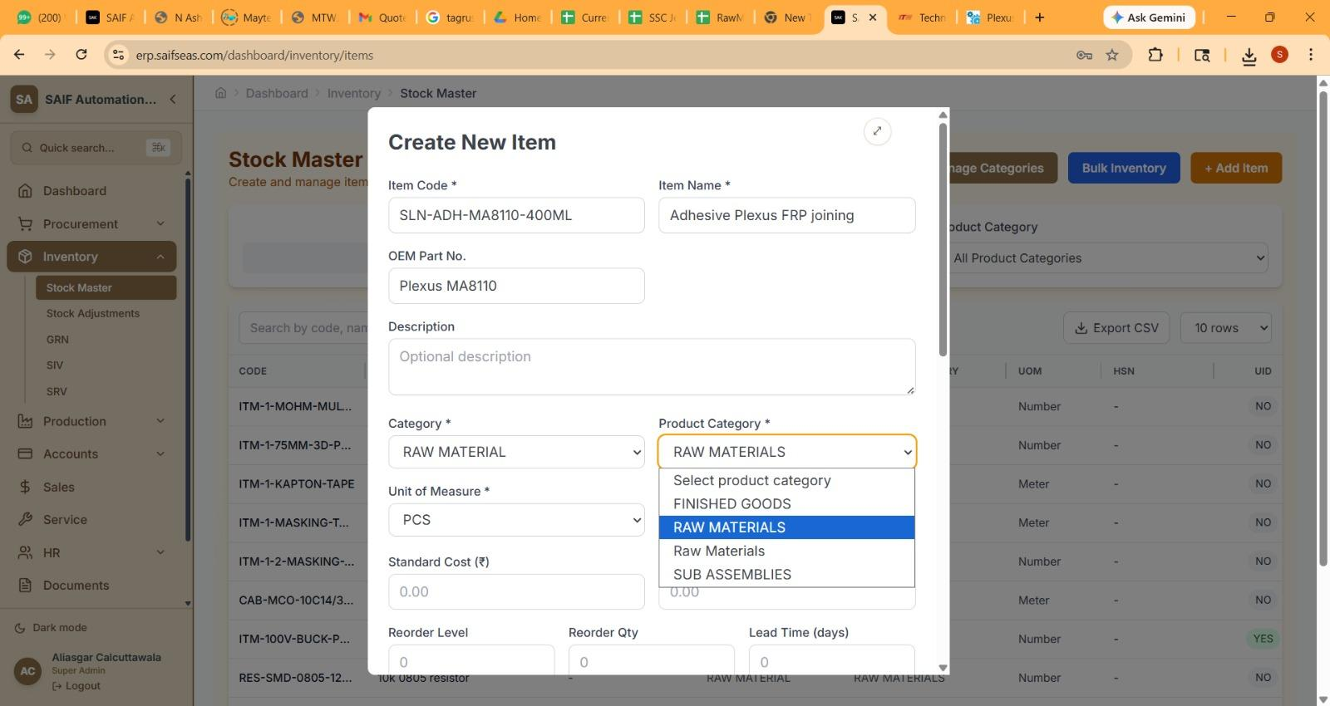here 2 times category -"Raw Material" is coming

In Category
- Raw Material
- Capital Goods
- Consumable
- Packing Material
- Services

Here we need to have a Service Category also, for various Items which are service oriented,
Like machining Cost, Painting Cost, Carpenter Cost.
for Them, Service Order instead of Purchase Order to be issued.

Stored Delivery Addresses for Purchase Requisition and Purchase Orders

Purchase Order
Purchase Order Status Update
1. When in Draft Mode - Draft - This is in case a PO is in draft state and not forwarded for approval.
2. Pending for Approval - This is after the PO Created and Forwarded to Approval Authority for Approving it.
3. When in Pending for Approval then the Intimation through Pop Up at Approving Authority to Approve it. We can later integrate the same with WhatsApp Message for reminder
4. After approval done Approved. When it is getting Approved, then automatically from System the Order should go to the Vendor.
5. When Tracking Status Updated, then it should show Under Transit
6. When GRN Done GRN Done. At this stage the UID should get Generated. Currently UID is generated after QC. The Idea is the Stores in charge is suppose to do the Exercise of UID, So, when material comes, he creates UID and stick on the Product and then send for QC. In case QC rejects a specific material, that UID will be selected and Rejected and hence Debit Note issued.
7. After GRN is Done, the Intimation should go to the User who is suppose to do the QC to come and update the QC and also reminder in case he does not complete should keep on Poping on his Home Screen, Later we can integrate the same with Whatsapp. QC Done
8. When Payment Done in full Payment Done, and in case Part Payment Done Partial Payment which will change to Payment done when Partial Payment is completed.

Accounts Payable
1. User Asik_a, tried to update the Payment of Zenya but it showed that the GRN Not Found.
2. From his Logging he is unable to view Invoices under Accounts Payable.
3. Invoice for Kalpana Enterprise - The Amount Details not coming. It is showing as Paid, even though Payment Entry not yet recorded.
4. Can we have Multiple Payment possible against Invoice, Like Advance Payment a certain Amount Done, Then Part Payment done and then Final Amount. The Total payment should be restricted to the Invoice Value and More Payment cannot be Done.
5. When Payment is done, option of TDS, or Short payment AMount to be added to be given, For Example in case TDS is deducted, then that amount to be shown as TDS, or another Field when Short Payment or for any reason some amount deducted is entered and there after the Invoice is Closed for Payment

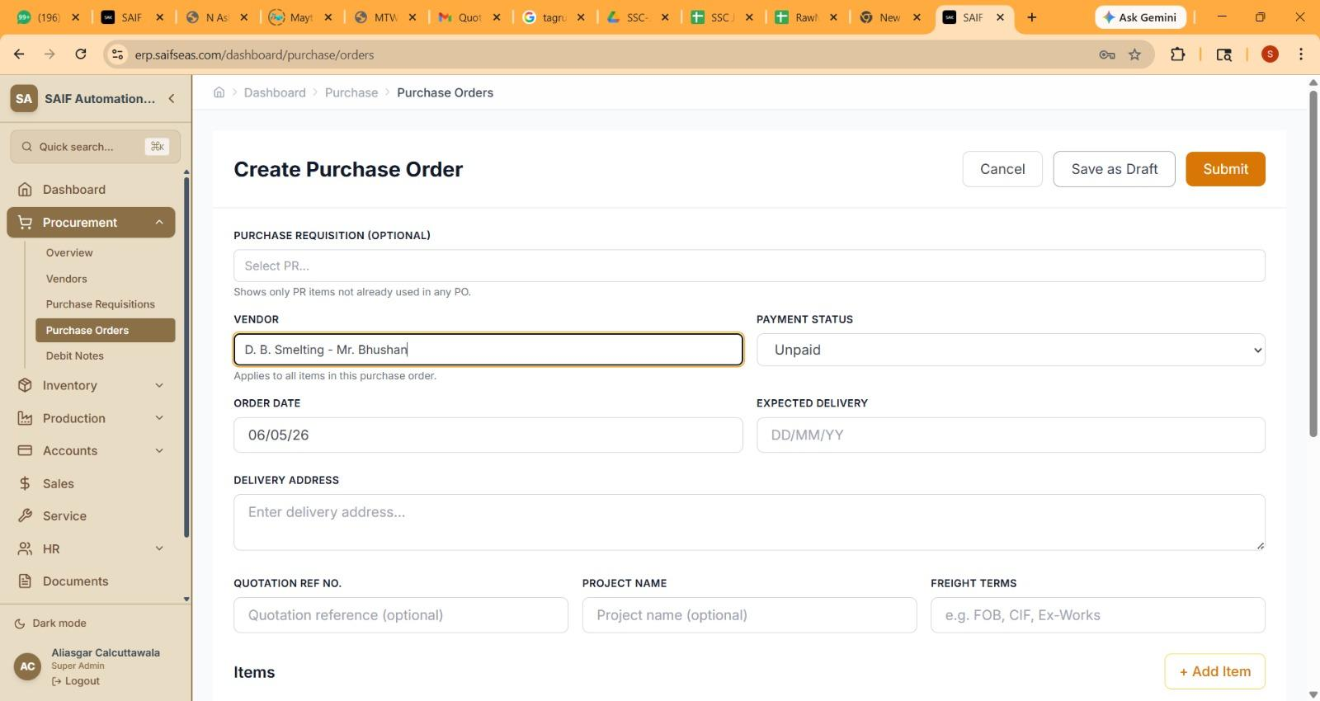
vendor name is not coming in proper A-Z order
